Stock Price Prediction

Ajit Kolekar

Get stock data for the past three years using getSymbols() function in quantmod package

#Load library  
library(quantmod)

## Warning: package 'quantmod' was built under R version 4.0.5

## Loading required package: xts

## Warning: package 'xts' was built under R version 4.0.3

## Loading required package: zoo

## Warning: package 'zoo' was built under R version 4.0.3

##   
## Attaching package: 'zoo'

## The following objects are masked from 'package:base':  
##   
## as.Date, as.Date.numeric

## Loading required package: TTR

## Warning: package 'TTR' was built under R version 4.0.3

## Registered S3 method overwritten by 'quantmod':  
## method from  
## as.zoo.data.frame zoo

# Set start date to a date three year's in the past from today  
start_date <- Sys.Date() - 1095 #Three years  
  
# Set end date to yesterday's date since the market might still be open today  
end_date <- Sys.Date() - 1  
  
# Set the symbol of the stock to analyze and predict  
symbol <- "MSFT"  
  
stock_df <- NULL  
  
# Get stock data  
stock_data <- getSymbols(Symbols = symbol, src = "yahoo", from = start_date,   
 to = end_date, auto.assign = FALSE)

## 'getSymbols' currently uses auto.assign=TRUE by default, but will  
## use auto.assign=FALSE in 0.5-0. You will still be able to use  
## 'loadSymbols' to automatically load data. getOption("getSymbols.env")  
## and getOption("getSymbols.auto.assign") will still be checked for  
## alternate defaults.  
##   
## This message is shown once per session and may be disabled by setting   
## options("getSymbols.warning4.0"=FALSE). See ?getSymbols for details.

stock_data <- Cl(stock_data)  
  
# Check the first few rows of stock data  
head(stock_data)

## MSFT.Close  
## 2019-01-25 107.17  
## 2019-01-28 105.08  
## 2019-01-29 102.94  
## 2019-01-30 106.38  
## 2019-01-31 104.43  
## 2019-02-01 102.78

Analyze the stock using technical indicators such as Simple Moving Average, Bollinger bands, Relative Strength Index, and Moving Average Convergence Divergence

#stock charting  
chart_Series(stock_data, col = "black")

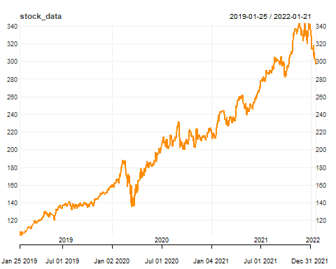

add_SMA(n = 100, on = 1, col = "red")

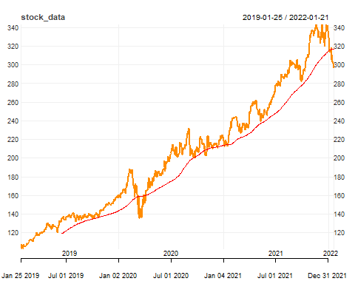

add_SMA(n = 20, on = 1, col = "black")

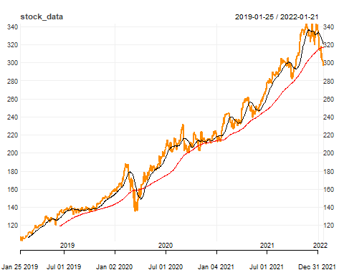

add_RSI(n = 14, maType = "SMA")

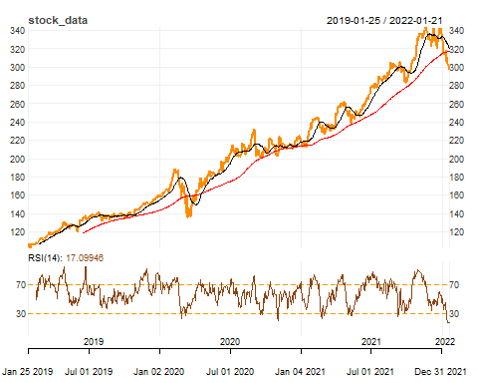

add_BBands(n = 20, maType = "SMA", sd = 1, on = -1)

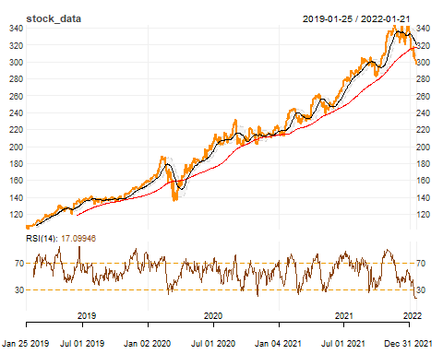

add_MACD(fast = 12, slow = 25, signal = 9, maType = "SMA", histogram = TRUE)

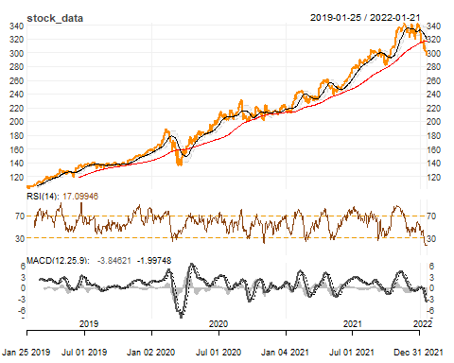

Convert the stock data into log transformation.

### Log tranformation stock data  
stock_log <- log(stock_data)  
head(stock_log, n = 10)

## MSFT.Close  
## 2019-01-25 4.674416  
## 2019-01-28 4.654722  
## 2019-01-29 4.634146  
## 2019-01-30 4.667018  
## 2019-01-31 4.648517  
## 2019-02-01 4.632591  
## 2019-02-04 4.660983  
## 2019-02-05 4.674883  
## 2019-02-06 4.663722  
## 2019-02-07 4.656528

Plot the log data

plot(stock_log, main = "log stock data chart")

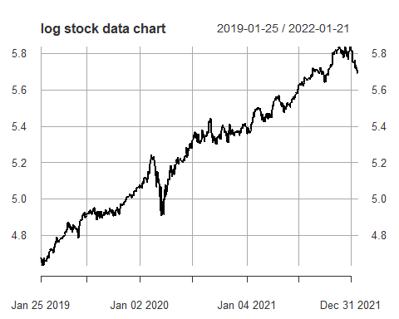

Plot auto correlation function of the log data

acf_log <- acf(stock_log, lag.max = 500)

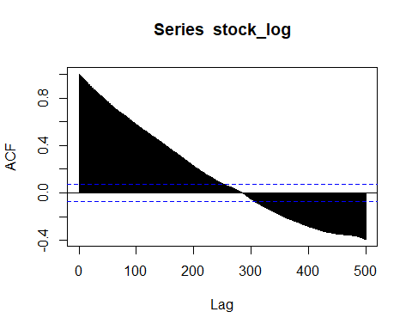

Plot partial auto correlation function of the log data

pacf_log <- pacf(stock_log, lag.max = 500)

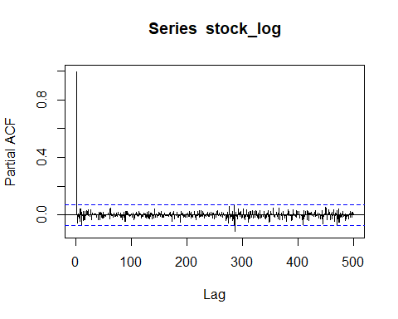

Plot the log transformed data will be differenced by 1 lag.

### difference logged data  
stock_diff <- diff(stock_log, lag = 1)  
  
stock_diff <- na.locf(stock_diff, na.rm = TRUE,  
 fromLast = TRUE)  
plot(stock_diff)

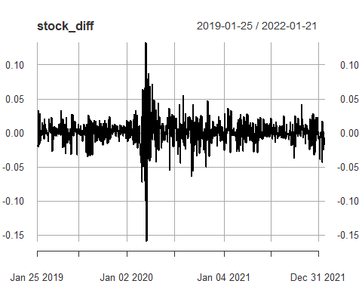

Split the data into training data and testing data. The last 100 days will be used as testing data.

### splitting into train and test data  
library(caTools)

## Warning: package 'caTools' was built under R version 4.0.5

size <- length(stock_diff) - 100  
train_data <- stock_diff[1:size]

# ARIMA Model

Build the ARIMA model

library(forecast)

## Warning: package 'forecast' was built under R version 4.0.3

set.seed(123)  
arima_model <- auto.arima(train_data, stationary = TRUE, ic = c("aicc", "aic", "bic"),   
 trace = TRUE)

##   
## Fitting models using approximations to speed things up...  
##   
## ARIMA(2,0,2) with non-zero mean : -3349.079  
## ARIMA(0,0,0) with non-zero mean : -3277.939  
## ARIMA(1,0,0) with non-zero mean : -3350.475  
## ARIMA(0,0,1) with non-zero mean : -3340.941  
## ARIMA(0,0,0) with zero mean : -3275.882  
## ARIMA(2,0,0) with non-zero mean : -3349.778  
## ARIMA(1,0,1) with non-zero mean : -3348.451  
## ARIMA(2,0,1) with non-zero mean : -3349.001  
## ARIMA(1,0,0) with zero mean : -3344.324  
##   
## Now re-fitting the best model(s) without approximations...  
##   
## ARIMA(1,0,0) with non-zero mean : -3350.202  
##   
## Best model: ARIMA(1,0,0) with non-zero mean

Display the summary details of the best ARIMA model

summary(arima_model)

## Series: train_data   
## ARIMA(1,0,0) with non-zero mean   
##   
## Coefficients:  
## ar1 mean  
## -0.3275 0.0016  
## s.e. 0.0369 0.0006  
##   
## sigma^2 estimated as 0.0003495: log likelihood=1678.12  
## AIC=-3350.24 AICc=-3350.2 BIC=-3336.79  
##   
## Training set error measures:  
## ME RMSE MAE MPE MAPE MASE ACF1  
## Training set -8.83646e-06 0.01866622 0.01273215 NaN Inf 0.6331416 0.002261477

Diagnostic checking of the best ARIMA model

checkresiduals(arima_model)

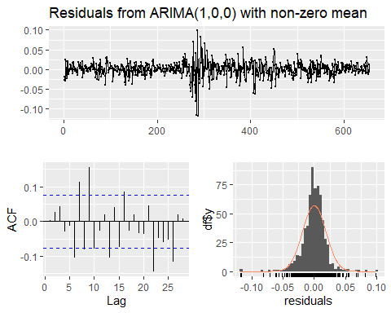

##   
## Ljung-Box test  
##   
## data: Residuals from ARIMA(1,0,0) with non-zero mean  
## Q* = 43.178, df = 8, p-value = 8.133e-07  
##   
## Model df: 2. Total lags used: 10

Fit the model into the training data set.

arima <- arima(train_data, order = c(1, 0, 0))  
summary(arima)

##   
## Call:  
## arima(x = train_data, order = c(1, 0, 0))  
##   
## Coefficients:  
## ar1 intercept  
## -0.3275 0.0016  
## s.e. 0.0369 0.0006  
##   
## sigma^2 estimated as 0.0003484: log likelihood = 1678.12, aic = -3350.24  
##   
## Training set error measures:  
## ME RMSE MAE MPE MAPE MASE ACF1  
## Training set -8.83646e-06 0.01866622 0.01273215 NaN Inf 0.6331416 0.002261477

Forecast the data using ARIMA model

forecast1 <- forecast(arima, h = 100)  
plot(forecast1)

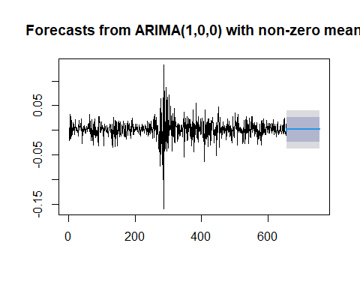

arima <- arima(stock_log[1:size], order = c(1, 0, 0))  
summary(arima)

##   
## Call:  
## arima(x = stock_log[1:size], order = c(1, 0, 0))  
##   
## Coefficients:  
## ar1 intercept  
## 0.9990 5.1908  
## s.e. 0.0013 0.3784  
##   
## sigma^2 estimated as 0.0003927: log likelihood = 1635.9, aic = -3265.8  
##   
## Training set error measures:  
## ME RMSE MAE MPE MAPE MASE  
## Training set 0.001552968 0.01981685 0.01305663 0.02886973 0.2527975 1.000231  
## ACF1  
## Training set -0.3264569

Plot the forecast

forecast_ori <- forecast(arima, h = 100)  
a <- ts(stock_log)  
forecast_ori %>% autoplot() + autolayer(a)

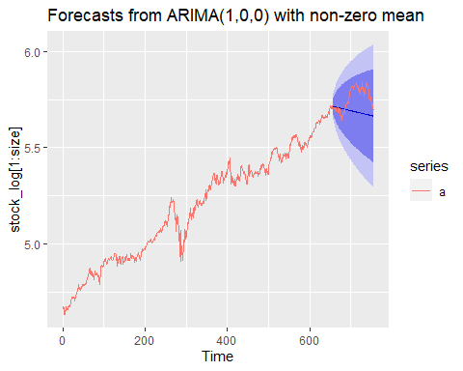

# GARCH Model

Model 1: Fit ARMA(0,0) GARCH(1,1) model with Student t-distribution

library(rugarch)

## Warning: package 'rugarch' was built under R version 4.0.5

## Loading required package: parallel

##   
## Attaching package: 'rugarch'

## The following object is masked from 'package:stats':  
##   
## sigma

garch_1 <- ugarchspec(mean.model = list(armaOrder=c(0,0)),variance.model = list(model = 'eGARCH',   
 garchOrder = c(1, 1)),distribution = 'std')  
fit_garch_1 <- ugarchfit(spec = garch_1, data= stock_diff)  
fit_garch_1

##   
## *---------------------------------*  
## * GARCH Model Fit *  
## *---------------------------------*  
##   
## Conditional Variance Dynamics   
## -----------------------------------  
## GARCH Model : eGARCH(1,1)  
## Mean Model : ARFIMA(0,0,0)  
## Distribution : std   
##   
## Optimal Parameters  
## ------------------------------------  
## Estimate Std. Error t value Pr(>|t|)  
## mu 0.001608 0.000891 1.8051 0.071058  
## omega -0.375879 0.093910 -4.0025 0.000063  
## alpha1 -0.105757 0.039678 -2.6653 0.007691  
## beta1 0.955266 0.011328 84.3260 0.000000  
## gamma1 0.273877 0.053281 5.1403 0.000000  
## shape 6.500052 1.519397 4.2780 0.000019  
##   
## Robust Standard Errors:  
## Estimate Std. Error t value Pr(>|t|)  
## mu 0.001608 0.001549 1.0377 0.299397  
## omega -0.375879 0.066896 -5.6189 0.000000  
## alpha1 -0.105757 0.052317 -2.0215 0.043231  
## beta1 0.955266 0.008531 111.9712 0.000000  
## gamma1 0.273877 0.059047 4.6383 0.000004  
## shape 6.500052 1.476174 4.4033 0.000011  
##   
## LogLikelihood : 2103.952   
##   
## Information Criteria  
## ------------------------------------  
##   
## Akaike -5.5575  
## Bayes -5.5207  
## Shibata -5.5576  
## Hannan-Quinn -5.5433  
##   
## Weighted Ljung-Box Test on Standardized Residuals  
## ------------------------------------  
## statistic p-value  
## Lag[1] 6.143 0.01319  
## Lag[2*(p+q)+(p+q)-1][2] 6.219 0.01923  
## Lag[4*(p+q)+(p+q)-1][5] 6.525 0.06752  
## d.o.f=0  
## H0 : No serial correlation  
##   
## Weighted Ljung-Box Test on Standardized Squared Residuals  
## ------------------------------------  
## statistic p-value  
## Lag[1] 0.5411 0.4620  
## Lag[2*(p+q)+(p+q)-1][5] 0.6651 0.9295  
## Lag[4*(p+q)+(p+q)-1][9] 1.3194 0.9690  
## d.o.f=2  
##   
## Weighted ARCH LM Tests  
## ------------------------------------  
## Statistic Shape Scale P-Value  
## ARCH Lag[3] 0.0009427 0.500 2.000 0.9755  
## ARCH Lag[5] 0.2515166 1.440 1.667 0.9529  
## ARCH Lag[7] 0.7088987 2.315 1.543 0.9558  
##   
## Nyblom stability test  
## ------------------------------------  
## Joint Statistic: 1.2325  
## Individual Statistics:   
## mu 0.1192  
## omega 0.1372  
## alpha1 0.1735  
## beta1 0.1219  
## gamma1 0.4600  
## shape 0.1074  
##   
## Asymptotic Critical Values (10% 5% 1%)  
## Joint Statistic: 1.49 1.68 2.12  
## Individual Statistic: 0.35 0.47 0.75  
##   
## Sign Bias Test  
## ------------------------------------  
## t-value prob sig  
## Sign Bias 0.03575 0.9715   
## Negative Sign Bias 0.34594 0.7295   
## Positive Sign Bias 1.43296 0.1523   
## Joint Effect 2.83414 0.4179   
##   
##   
## Adjusted Pearson Goodness-of-Fit Test:  
## ------------------------------------  
## group statistic p-value(g-1)  
## 1 20 20.55 0.36221  
## 2 30 45.46 0.02651  
## 3 40 32.44 0.76173  
## 4 50 65.86 0.05422  
##   
##   
## Elapsed time : 0.552063

Model 2: Fit ARMA(1,1) GARCH(1,1) model with Student t-distribution

garch_2 <- ugarchspec(mean.model = list(armaOrder=c(1,1)),variance.model = list(model = 'eGARCH',   
 garchOrder = c(1, 1)),distribution = 'std')  
  
fit_garch_2 <- ugarchfit(spec = garch_2, data= stock_diff)  
fit_garch_2

##   
## *---------------------------------*  
## * GARCH Model Fit *  
## *---------------------------------*  
##   
## Conditional Variance Dynamics   
## -----------------------------------  
## GARCH Model : eGARCH(1,1)  
## Mean Model : ARFIMA(1,0,1)  
## Distribution : std   
##   
## Optimal Parameters  
## ------------------------------------  
## Estimate Std. Error t value Pr(>|t|)  
## mu 0.001743 0.000248 7.0246 0.000000  
## ar1 0.571075 0.035678 16.0064 0.000000  
## ma1 -0.660993 0.035000 -18.8856 0.000000  
## omega -0.373662 0.095150 -3.9271 0.000086  
## alpha1 -0.090209 0.032997 -2.7338 0.006260  
## beta1 0.955627 0.011310 84.4937 0.000000  
## gamma1 0.276212 0.052515 5.2597 0.000000  
## shape 6.225546 1.409185 4.4178 0.000010  
##   
## Robust Standard Errors:  
## Estimate Std. Error t value Pr(>|t|)  
## mu 0.001743 0.000171 10.1904 0.000000  
## ar1 0.571075 0.011099 51.4508 0.000000  
## ma1 -0.660993 0.014293 -46.2468 0.000000  
## omega -0.373662 0.064812 -5.7653 0.000000  
## alpha1 -0.090209 0.033248 -2.7133 0.006663  
## beta1 0.955627 0.007637 125.1250 0.000000  
## gamma1 0.276212 0.055875 4.9434 0.000001  
## shape 6.225546 1.223137 5.0898 0.000000  
##   
## LogLikelihood : 2108.601   
##   
## Information Criteria  
## ------------------------------------  
##   
## Akaike -5.5645  
## Bayes -5.5155  
## Shibata -5.5647  
## Hannan-Quinn -5.5456  
##   
## Weighted Ljung-Box Test on Standardized Residuals  
## ------------------------------------  
## statistic p-value  
## Lag[1] 0.07105 0.7898  
## Lag[2*(p+q)+(p+q)-1][5] 2.51642 0.7700  
## Lag[4*(p+q)+(p+q)-1][9] 3.43151 0.8150  
## d.o.f=2  
## H0 : No serial correlation  
##   
## Weighted Ljung-Box Test on Standardized Squared Residuals  
## ------------------------------------  
## statistic p-value  
## Lag[1] 0.04248 0.8367  
## Lag[2*(p+q)+(p+q)-1][5] 0.34636 0.9786  
## Lag[4*(p+q)+(p+q)-1][9] 1.12760 0.9803  
## d.o.f=2  
##   
## Weighted ARCH LM Tests  
## ------------------------------------  
## Statistic Shape Scale P-Value  
## ARCH Lag[3] 0.005467 0.500 2.000 0.9411  
## ARCH Lag[5] 0.397347 1.440 1.667 0.9134  
## ARCH Lag[7] 0.800068 2.315 1.543 0.9438  
##   
## Nyblom stability test  
## ------------------------------------  
## Joint Statistic: 1.5739  
## Individual Statistics:   
## mu 0.11685  
## ar1 0.23283  
## ma1 0.23372  
## omega 0.13265  
## alpha1 0.19888  
## beta1 0.11830  
## gamma1 0.45404  
## shape 0.09919  
##   
## Asymptotic Critical Values (10% 5% 1%)  
## Joint Statistic: 1.89 2.11 2.59  
## Individual Statistic: 0.35 0.47 0.75  
##   
## Sign Bias Test  
## ------------------------------------  
## t-value prob sig  
## Sign Bias 0.6043 0.5458   
## Negative Sign Bias 0.3608 0.7184   
## Positive Sign Bias 0.5611 0.5749   
## Joint Effect 1.4209 0.7006   
##   
##   
## Adjusted Pearson Goodness-of-Fit Test:  
## ------------------------------------  
## group statistic p-value(g-1)  
## 1 20 30.56 0.04506  
## 2 30 36.56 0.15774  
## 3 40 54.80 0.04790  
## 4 50 65.86 0.05422  
##   
##   
## Elapsed time : 0.8849471

Model 3: Fit ARMA(2,2) GARCH(1,1) model with Student t-distribution

garch_3 <- ugarchspec(mean.model = list(armaOrder=c(2,2)),variance.model = list(model = 'eGARCH',   
 garchOrder = c(1, 1)),distribution = 'std')  
  
fit_garch_3 <- ugarchfit(spec = garch_3, data= stock_diff)  
fit_garch_3

##   
## *---------------------------------*  
## * GARCH Model Fit *  
## *---------------------------------*  
##   
## Conditional Variance Dynamics   
## -----------------------------------  
## GARCH Model : eGARCH(1,1)  
## Mean Model : ARFIMA(2,0,2)  
## Distribution : std   
##   
## Optimal Parameters  
## ------------------------------------  
## Estimate Std. Error t value Pr(>|t|)  
## mu 0.001813 0.000900 2.01481 0.043925  
## ar1 0.836020 0.059363 14.08326 0.000000  
## ar2 0.069202 0.179564 0.38539 0.699951  
## ma1 -0.940674 0.163473 -5.75431 0.000000  
## ma2 -0.003803 0.013777 -0.27606 0.782501  
## omega -0.400947 0.127601 -3.14219 0.001677  
## alpha1 -0.086977 0.036973 -2.35242 0.018652  
## beta1 0.952410 0.015802 60.27116 0.000000  
## gamma1 0.282173 0.054948 5.13530 0.000000  
## shape 6.306712 1.651783 3.81813 0.000134  
##   
## Robust Standard Errors:  
## Estimate Std. Error t value Pr(>|t|)  
## mu 0.001813 0.005008 0.362081 0.717291  
## ar1 0.836020 0.231647 3.609024 0.000307  
## ar2 0.069202 1.007178 0.068708 0.945222  
## ma1 -0.940674 0.905814 -1.038485 0.299044  
## ma2 -0.003803 0.053594 -0.070963 0.943427  
## omega -0.400947 0.412378 -0.972280 0.330911  
## alpha1 -0.086977 0.089466 -0.972176 0.330963  
## beta1 0.952410 0.055356 17.205056 0.000000  
## gamma1 0.282173 0.092181 3.061074 0.002205  
## shape 6.306712 4.915207 1.283102 0.199456  
##   
## LogLikelihood : 2109.514   
##   
## Information Criteria  
## ------------------------------------  
##   
## Akaike -5.5616  
## Bayes -5.5003  
## Shibata -5.5620  
## Hannan-Quinn -5.5380  
##   
## Weighted Ljung-Box Test on Standardized Residuals  
## ------------------------------------  
## statistic p-value  
## Lag[1] 0.002521 0.9600  
## Lag[2*(p+q)+(p+q)-1][11] 2.192615 1.0000  
## Lag[4*(p+q)+(p+q)-1][19] 6.691792 0.9328  
## d.o.f=4  
## H0 : No serial correlation  
##   
## Weighted Ljung-Box Test on Standardized Squared Residuals  
## ------------------------------------  
## statistic p-value  
## Lag[1] 0.01918 0.8899  
## Lag[2*(p+q)+(p+q)-1][5] 0.26643 0.9870  
## Lag[4*(p+q)+(p+q)-1][9] 1.03055 0.9850  
## d.o.f=2  
##   
## Weighted ARCH LM Tests  
## ------------------------------------  
## Statistic Shape Scale P-Value  
## ARCH Lag[3] 0.04512 0.500 2.000 0.8318  
## ARCH Lag[5] 0.43420 1.440 1.667 0.9029  
## ARCH Lag[7] 0.79121 2.315 1.543 0.9450  
##   
## Nyblom stability test  
## ------------------------------------  
## Joint Statistic: 2.3298  
## Individual Statistics:   
## mu 0.16298  
## ar1 0.16653  
## ar2 0.09837  
## ma1 0.06348  
## ma2 0.03264  
## omega 0.13134  
## alpha1 0.18615  
## beta1 0.11721  
## gamma1 0.40609  
## shape 0.09573  
##   
## Asymptotic Critical Values (10% 5% 1%)  
## Joint Statistic: 2.29 2.54 3.05  
## Individual Statistic: 0.35 0.47 0.75  
##   
## Sign Bias Test  
## ------------------------------------  
## t-value prob sig  
## Sign Bias 0.3275 0.7434   
## Negative Sign Bias 0.2118 0.8324   
## Positive Sign Bias 0.6767 0.4988   
## Joint Effect 1.1022 0.7765   
##   
##   
## Adjusted Pearson Goodness-of-Fit Test:  
## ------------------------------------  
## group statistic p-value(g-1)  
## 1 20 18.27 0.5044  
## 2 30 29.81 0.4236  
## 3 40 41.34 0.3686  
## 4 50 47.45 0.5361  
##   
##   
## Elapsed time : 1.383544

Model 4: Fit ARMA(1,2) GARCH(1,1) model with Student t-distribution

garch_4 <- ugarchspec(mean.model = list(armaOrder=c(1,2)),variance.model = list(model = 'eGARCH',   
 garchOrder = c(1, 1)),distribution = 'std')  
  
fit_garch_4 <- ugarchfit(spec = garch_4, data=stock_diff)  
fit_garch_4

##   
## *---------------------------------*  
## * GARCH Model Fit *  
## *---------------------------------*  
##   
## Conditional Variance Dynamics   
## -----------------------------------  
## GARCH Model : eGARCH(1,1)  
## Mean Model : ARFIMA(1,0,2)  
## Distribution : std   
##   
## Optimal Parameters  
## ------------------------------------  
## Estimate Std. Error t value Pr(>|t|)  
## mu 0.001547 0.000001 1.7591e+03 0.000000  
## ar1 0.958243 0.012667 7.5652e+01 0.000000  
## ma1 -1.083160 0.000049 -2.2112e+04 0.000000  
## ma2 0.072552 0.000039 1.8820e+03 0.000000  
## omega -0.445729 0.131499 -3.3896e+00 0.000700  
## alpha1 -0.049485 0.059413 -8.3291e-01 0.404895  
## beta1 0.946750 0.015738 6.0155e+01 0.000000  
## gamma1 0.337689 0.072778 4.6400e+00 0.000003  
## shape 7.259170 1.814080 4.0016e+00 0.000063  
##   
## Robust Standard Errors:  
## Estimate Std. Error t value Pr(>|t|)  
## mu 0.001547 0.000010 162.87987 0.00000  
## ar1 0.958243 0.025539 37.52096 0.00000  
## ma1 -1.083160 0.000571 -1896.63784 0.00000  
## ma2 0.072552 0.000045 1610.69362 0.00000  
## omega -0.445729 0.803045 -0.55505 0.57886  
## alpha1 -0.049485 0.450832 -0.10977 0.91260  
## beta1 0.946750 0.090656 10.44332 0.00000  
## gamma1 0.337689 0.561060 0.60188 0.54726  
## shape 7.259170 1.982183 3.66221 0.00025  
##   
## LogLikelihood : 2115.433   
##   
## Information Criteria  
## ------------------------------------  
##   
## Akaike -5.5800  
## Bayes -5.5248  
## Shibata -5.5802  
## Hannan-Quinn -5.5587  
##   
## Weighted Ljung-Box Test on Standardized Residuals  
## ------------------------------------  
## statistic p-value  
## Lag[1] 0.01813 0.8929  
## Lag[2*(p+q)+(p+q)-1][8] 1.19831 1.0000  
## Lag[4*(p+q)+(p+q)-1][14] 3.39556 0.9922  
## d.o.f=3  
## H0 : No serial correlation  
##   
## Weighted Ljung-Box Test on Standardized Squared Residuals  
## ------------------------------------  
## statistic p-value  
## Lag[1] 0.1500 0.6986  
## Lag[2*(p+q)+(p+q)-1][5] 0.3428 0.9790  
## Lag[4*(p+q)+(p+q)-1][9] 1.2681 0.9723  
## d.o.f=2  
##   
## Weighted ARCH LM Tests  
## ------------------------------------  
## Statistic Shape Scale P-Value  
## ARCH Lag[3] 0.1529 0.500 2.000 0.6958  
## ARCH Lag[5] 0.4130 1.440 1.667 0.9089  
## ARCH Lag[7] 0.8671 2.315 1.543 0.9342  
##   
## Nyblom stability test  
## ------------------------------------  
## Joint Statistic: 2.0648  
## Individual Statistics:   
## mu 0.02267  
## ar1 0.04147  
## ma1 0.02212  
## ma2 0.02272  
## omega 0.15350  
## alpha1 0.24317  
## beta1 0.14329  
## gamma1 0.31904  
## shape 0.12838  
##   
## Asymptotic Critical Values (10% 5% 1%)  
## Joint Statistic: 2.1 2.32 2.82  
## Individual Statistic: 0.35 0.47 0.75  
##   
## Sign Bias Test  
## ------------------------------------  
## t-value prob sig  
## Sign Bias 0.07087 0.9435   
## Negative Sign Bias 0.03762 0.9700   
## Positive Sign Bias 0.62189 0.5342   
## Joint Effect 0.47932 0.9234   
##   
##   
## Adjusted Pearson Goodness-of-Fit Test:  
## ------------------------------------  
## group statistic p-value(g-1)  
## 1 20 25.32 0.15034  
## 2 30 31.40 0.34694  
## 3 40 57.56 0.02802  
## 4 50 60.17 0.13172  
##   
##   
## Elapsed time : 2.767403

Model 5: Fit ARMA(2,1) GARCH(1,1) model with Student t-distribution

garch_5 <- ugarchspec(mean.model = list(armaOrder=c(2,1)),variance.model = list(model = 'eGARCH',   
 garchOrder = c(1, 1)),distribution = 'std')  
  
fit_garch_5 <- ugarchfit(spec = garch_5, data=stock_diff)  
fit_garch_5

##   
## *---------------------------------*  
## * GARCH Model Fit *  
## *---------------------------------*  
##   
## Conditional Variance Dynamics   
## -----------------------------------  
## GARCH Model : eGARCH(1,1)  
## Mean Model : ARFIMA(2,0,1)  
## Distribution : std   
##   
## Optimal Parameters  
## ------------------------------------  
## Estimate Std. Error t value Pr(>|t|)  
## mu 0.001812 0.000049 36.9605 0.000000  
## ar1 0.839871 0.045257 18.5579 0.000000  
## ar2 0.065597 0.047604 1.3780 0.168209  
## ma1 -0.944523 0.028080 -33.6371 0.000000  
## omega -0.400534 0.102980 -3.8894 0.000100  
## alpha1 -0.086981 0.034154 -2.5467 0.010873  
## beta1 0.952457 0.012176 78.2258 0.000000  
## gamma1 0.281993 0.053109 5.3097 0.000000  
## shape 6.325076 1.427250 4.4317 0.000009  
##   
## Robust Standard Errors:  
## Estimate Std. Error t value Pr(>|t|)  
## mu 0.001812 0.000314 5.76494 0.000000  
## ar1 0.839871 0.032237 26.05296 0.000000  
## ar2 0.065597 0.075729 0.86621 0.386376  
## ma1 -0.944523 0.069132 -13.66255 0.000000  
## omega -0.400534 0.079056 -5.06648 0.000000  
## alpha1 -0.086981 0.034417 -2.52729 0.011495  
## beta1 0.952457 0.009376 101.58843 0.000000  
## gamma1 0.281993 0.057331 4.91869 0.000001  
## shape 6.325076 1.276267 4.95592 0.000001  
##   
## LogLikelihood : 2109.514   
##   
## Information Criteria  
## ------------------------------------  
##   
## Akaike -5.5643  
## Bayes -5.5091  
## Shibata -5.5646  
## Hannan-Quinn -5.5430  
##   
## Weighted Ljung-Box Test on Standardized Residuals  
## ------------------------------------  
## statistic p-value  
## Lag[1] 0.002424 0.9607  
## Lag[2*(p+q)+(p+q)-1][8] 1.301116 1.0000  
## Lag[4*(p+q)+(p+q)-1][14] 3.642094 0.9868  
## d.o.f=3  
## H0 : No serial correlation  
##   
## Weighted Ljung-Box Test on Standardized Squared Residuals  
## ------------------------------------  
## statistic p-value  
## Lag[1] 0.01939 0.8893  
## Lag[2*(p+q)+(p+q)-1][5] 0.26727 0.9870  
## Lag[4*(p+q)+(p+q)-1][9] 1.03110 0.9849  
## d.o.f=2  
##   
## Weighted ARCH LM Tests  
## ------------------------------------  
## Statistic Shape Scale P-Value  
## ARCH Lag[3] 0.04499 0.500 2.000 0.8320  
## ARCH Lag[5] 0.43419 1.440 1.667 0.9029  
## ARCH Lag[7] 0.79095 2.315 1.543 0.9450  
##   
## Nyblom stability test  
## ------------------------------------  
## Joint Statistic: 2.1412  
## Individual Statistics:   
## mu 0.15077  
## ar1 0.16755  
## ar2 0.09752  
## ma1 0.06510  
## omega 0.13108  
## alpha1 0.18619  
## beta1 0.11701  
## gamma1 0.40642  
## shape 0.09375  
##   
## Asymptotic Critical Values (10% 5% 1%)  
## Joint Statistic: 2.1 2.32 2.82  
## Individual Statistic: 0.35 0.47 0.75  
##   
## Sign Bias Test  
## ------------------------------------  
## t-value prob sig  
## Sign Bias 0.3765 0.7067   
## Negative Sign Bias 0.2338 0.8152   
## Positive Sign Bias 0.6506 0.5155   
## Joint Effect 1.1371 0.7681   
##   
##   
## Adjusted Pearson Goodness-of-Fit Test:  
## ------------------------------------  
## group statistic p-value(g-1)  
## 1 20 18.27 0.5044  
## 2 30 29.25 0.4520  
## 3 40 40.18 0.4178  
## 4 50 45.99 0.5958  
##   
##   
## Elapsed time : 1.484998

Model 6: Fit ARMA(3,1) GARCH(1,1) model with Student t-distribution

garch_6 <- ugarchspec(mean.model = list(armaOrder=c(3,1)),variance.model = list(model = 'eGARCH',   
 garchOrder = c(1, 1)),distribution = 'std')  
  
fit_garch_6 <- ugarchfit(spec = garch_6, data=stock_diff)  
fit_garch_6

##   
## *---------------------------------*  
## * GARCH Model Fit *  
## *---------------------------------*  
##   
## Conditional Variance Dynamics   
## -----------------------------------  
## GARCH Model : eGARCH(1,1)  
## Mean Model : ARFIMA(3,0,1)  
## Distribution : std   
##   
## Optimal Parameters  
## ------------------------------------  
## Estimate Std. Error t value Pr(>|t|)  
## mu 0.001684 0.000318 5.3039 0.000000  
## ar1 -0.831206 0.025146 -33.0553 0.000000  
## ar2 -0.106053 0.019617 -5.4063 0.000000  
## ar3 -0.017930 0.010393 -1.7251 0.084508  
## ma1 0.723344 0.026213 27.5948 0.000000  
## omega -0.354918 0.085406 -4.1556 0.000032  
## alpha1 -0.096023 0.033290 -2.8844 0.003921  
## beta1 0.957829 0.010153 94.3391 0.000000  
## gamma1 0.261719 0.050853 5.1466 0.000000  
## shape 6.390033 1.466540 4.3572 0.000013  
##   
## Robust Standard Errors:  
## Estimate Std. Error t value Pr(>|t|)  
## mu 0.001684 0.000251 6.7158 0.000000  
## ar1 -0.831206 0.010531 -78.9282 0.000000  
## ar2 -0.106053 0.010400 -10.1977 0.000000  
## ar3 -0.017930 0.004811 -3.7265 0.000194  
## ma1 0.723344 0.011138 64.9455 0.000000  
## omega -0.354918 0.054461 -6.5169 0.000000  
## alpha1 -0.096023 0.033345 -2.8797 0.003981  
## beta1 0.957829 0.006408 149.4749 0.000000  
## gamma1 0.261719 0.054240 4.8252 0.000001  
## shape 6.390033 1.308268 4.8843 0.000001  
##   
## LogLikelihood : 2108.434   
##   
## Information Criteria  
## ------------------------------------  
##   
## Akaike -5.5588  
## Bayes -5.4975  
## Shibata -5.5591  
## Hannan-Quinn -5.5352  
##   
## Weighted Ljung-Box Test on Standardized Residuals  
## ------------------------------------  
## statistic p-value  
## Lag[1] 0.006846 0.9341  
## Lag[2*(p+q)+(p+q)-1][11] 2.521879 1.0000  
## Lag[4*(p+q)+(p+q)-1][19] 7.159573 0.8936  
## d.o.f=4  
## H0 : No serial correlation  
##   
## Weighted Ljung-Box Test on Standardized Squared Residuals  
## ------------------------------------  
## statistic p-value  
## Lag[1] 0.1209 0.7281  
## Lag[2*(p+q)+(p+q)-1][5] 0.3158 0.9820  
## Lag[4*(p+q)+(p+q)-1][9] 1.0617 0.9836  
## d.o.f=2  
##   
## Weighted ARCH LM Tests  
## ------------------------------------  
## Statistic Shape Scale P-Value  
## ARCH Lag[3] 0.00616 0.500 2.000 0.9374  
## ARCH Lag[5] 0.42118 1.440 1.667 0.9066  
## ARCH Lag[7] 0.80569 2.315 1.543 0.9430  
##   
## Nyblom stability test  
## ------------------------------------  
## Joint Statistic: 2.0529  
## Individual Statistics:   
## mu 0.14204  
## ar1 0.17031  
## ar2 0.46753  
## ar3 0.38396  
## ma1 0.15093  
## omega 0.12580  
## alpha1 0.16836  
## beta1 0.11351  
## gamma1 0.43699  
## shape 0.08587  
##   
## Asymptotic Critical Values (10% 5% 1%)  
## Joint Statistic: 2.29 2.54 3.05  
## Individual Statistic: 0.35 0.47 0.75  
##   
## Sign Bias Test  
## ------------------------------------  
## t-value prob sig  
## Sign Bias 0.6649 0.5063   
## Negative Sign Bias 0.5007 0.6167   
## Positive Sign Bias 0.6237 0.5330   
## Joint Effect 1.7048 0.6359   
##   
##   
## Adjusted Pearson Goodness-of-Fit Test:  
## ------------------------------------  
## group statistic p-value(g-1)  
## 1 20 22.09 0.2800  
## 2 30 32.43 0.3013  
## 3 40 41.77 0.3514  
## 4 50 49.57 0.4504  
##   
##   
## Elapsed time : 1.329666

Model 7: Fit ARMA(3,2) GARCH(1,1) model with Student t-distribution

garch_7 <- ugarchspec(mean.model = list(armaOrder=c(3,2)),variance.model = list(model = 'eGARCH',   
 garchOrder = c(1, 1)),distribution = 'std')  
  
fit_garch_7 <- ugarchfit(spec = garch_7, data=stock_diff)  
fit_garch_7

##   
## *---------------------------------*  
## * GARCH Model Fit *  
## *---------------------------------*  
##   
## Conditional Variance Dynamics   
## -----------------------------------  
## GARCH Model : eGARCH(1,1)  
## Mean Model : ARFIMA(3,0,2)  
## Distribution : std   
##   
## Optimal Parameters  
## ------------------------------------  
## Estimate Std. Error t value Pr(>|t|)  
## mu 0.001684 0.000310 5.4277 0.000000  
## ar1 -1.690480 0.013408 -126.0805 0.000000  
## ar2 -1.094622 0.013262 -82.5356 0.000000  
## ar3 -0.086249 0.008872 -9.7215 0.000000  
## ma1 1.620426 0.008754 185.1130 0.000000  
## ma2 0.974432 0.001983 491.3700 0.000000  
## omega -0.370838 0.088508 -4.1899 0.000028  
## alpha1 -0.100240 0.034901 -2.8722 0.004077  
## beta1 0.955983 0.010507 90.9821 0.000000  
## gamma1 0.268469 0.052439 5.1196 0.000000  
## shape 6.054768 1.282436 4.7213 0.000002  
##   
## Robust Standard Errors:  
## Estimate Std. Error t value Pr(>|t|)  
## mu 0.001684 0.000214 7.8593 0.000000  
## ar1 -1.690480 0.021677 -77.9867 0.000000  
## ar2 -1.094622 0.012207 -89.6749 0.000000  
## ar3 -0.086249 0.006402 -13.4712 0.000000  
## ma1 1.620426 0.013575 119.3667 0.000000  
## ma2 0.974432 0.003036 321.0086 0.000000  
## omega -0.370838 0.081141 -4.5703 0.000005  
## alpha1 -0.100240 0.036141 -2.7736 0.005544  
## beta1 0.955983 0.009651 99.0601 0.000000  
## gamma1 0.268469 0.058112 4.6198 0.000004  
## shape 6.054768 1.183996 5.1138 0.000000  
##   
## LogLikelihood : 2111.642   
##   
## Information Criteria  
## ------------------------------------  
##   
## Akaike -5.5646  
## Bayes -5.4972  
## Shibata -5.5650  
## Hannan-Quinn -5.5386  
##   
## Weighted Ljung-Box Test on Standardized Residuals  
## ------------------------------------  
## statistic p-value  
## Lag[1] 0.2864 0.5925  
## Lag[2*(p+q)+(p+q)-1][14] 3.6011 1.0000  
## Lag[4*(p+q)+(p+q)-1][24] 8.4723 0.9507  
## d.o.f=5  
## H0 : No serial correlation  
##   
## Weighted Ljung-Box Test on Standardized Squared Residuals  
## ------------------------------------  
## statistic p-value  
## Lag[1] 0.3451 0.5569  
## Lag[2*(p+q)+(p+q)-1][5] 0.4039 0.9715  
## Lag[4*(p+q)+(p+q)-1][9] 0.9351 0.9888  
## d.o.f=2  
##   
## Weighted ARCH LM Tests  
## ------------------------------------  
## Statistic Shape Scale P-Value  
## ARCH Lag[3] 0.01758 0.500 2.000 0.8945  
## ARCH Lag[5] 0.11416 1.440 1.667 0.9841  
## ARCH Lag[7] 0.31778 2.315 1.543 0.9918  
##   
## Nyblom stability test  
## ------------------------------------  
## Joint Statistic: 1.7645  
## Individual Statistics:   
## mu 0.10642  
## ar1 0.13010  
## ar2 0.05738  
## ar3 0.04175  
## ma1 0.05733  
## ma2 0.03236  
## omega 0.13716  
## alpha1 0.18239  
## beta1 0.12450  
## gamma1 0.44864  
## shape 0.08246  
##   
## Asymptotic Critical Values (10% 5% 1%)  
## Joint Statistic: 2.49 2.75 3.27  
## Individual Statistic: 0.35 0.47 0.75  
##   
## Sign Bias Test  
## ------------------------------------  
## t-value prob sig  
## Sign Bias 0.02252 0.9820   
## Negative Sign Bias 0.40949 0.6823   
## Positive Sign Bias 1.13396 0.2572   
## Joint Effect 1.75802 0.6241   
##   
##   
## Adjusted Pearson Goodness-of-Fit Test:  
## ------------------------------------  
## group statistic p-value(g-1)  
## 1 20 19.54 0.4225  
## 2 30 26.87 0.5789  
## 3 40 35.20 0.6440  
## 4 50 54.21 0.2826  
##   
##   
## Elapsed time : 2.220658

Model 8: Fit ARMA(1,3) GARCH(1,1) model with Student t-distribution

garch_8 <- ugarchspec(mean.model = list(armaOrder=c(1,3)),variance.model = list(model = 'eGARCH',   
 garchOrder = c(1, 1)),distribution = 'std')  
  
fit_garch_8 <- ugarchfit(spec = garch_8, data=stock_diff)  
fit_garch_8

##   
## *---------------------------------*  
## * GARCH Model Fit *  
## *---------------------------------*  
##   
## Conditional Variance Dynamics   
## -----------------------------------  
## GARCH Model : eGARCH(1,1)  
## Mean Model : ARFIMA(1,0,3)  
## Distribution : std   
##   
## Optimal Parameters  
## ------------------------------------  
## Estimate Std. Error t value Pr(>|t|)  
## mu 0.001548 0.000001 1.6151e+03 0.000000  
## ar1 0.967501 0.013408 7.2158e+01 0.000000  
## ma1 -1.091740 0.000043 -2.5226e+04 0.000000  
## ma2 0.080498 0.000052 1.5417e+03 0.000000  
## ma3 0.000894 0.000022 4.0502e+01 0.000000  
## omega -0.389998 0.121933 -3.1985e+00 0.001382  
## alpha1 -0.056892 0.057033 -9.9754e-01 0.318503  
## beta1 0.953253 0.014573 6.5412e+01 0.000000  
## gamma1 0.321637 0.076218 4.2200e+00 0.000024  
## shape 7.252549 1.890121 3.8371e+00 0.000125  
##   
## Robust Standard Errors:  
## Estimate Std. Error t value Pr(>|t|)  
## mu 0.001548 0.000008 185.03815 0.000000  
## ar1 0.967501 0.024399 39.65400 0.000000  
## ma1 -1.091740 0.000466 -2342.02877 0.000000  
## ma2 0.080498 0.000088 913.54844 0.000000  
## ma3 0.000894 0.000016 54.76310 0.000000  
## omega -0.389998 0.477024 -0.81756 0.413606  
## alpha1 -0.056892 0.337277 -0.16868 0.866047  
## beta1 0.953253 0.052937 18.00716 0.000000  
## gamma1 0.321637 0.498538 0.64516 0.518823  
## shape 7.252549 2.041636 3.55232 0.000382  
##   
## LogLikelihood : 2115.19   
##   
## Information Criteria  
## ------------------------------------  
##   
## Akaike -5.5767  
## Bayes -5.5154  
## Shibata -5.5770  
## Hannan-Quinn -5.5531  
##   
## Weighted Ljung-Box Test on Standardized Residuals  
## ------------------------------------  
## statistic p-value  
## Lag[1] 0.00654 0.9355  
## Lag[2*(p+q)+(p+q)-1][11] 1.85848 1.0000  
## Lag[4*(p+q)+(p+q)-1][19] 6.07029 0.9679  
## d.o.f=4  
## H0 : No serial correlation  
##   
## Weighted Ljung-Box Test on Standardized Squared Residuals  
## ------------------------------------  
## statistic p-value  
## Lag[1] 0.06758 0.7949  
## Lag[2*(p+q)+(p+q)-1][5] 0.26208 0.9874  
## Lag[4*(p+q)+(p+q)-1][9] 1.14505 0.9794  
## d.o.f=2  
##   
## Weighted ARCH LM Tests  
## ------------------------------------  
## Statistic Shape Scale P-Value  
## ARCH Lag[3] 0.1599 0.500 2.000 0.6893  
## ARCH Lag[5] 0.4150 1.440 1.667 0.9084  
## ARCH Lag[7] 0.7914 2.315 1.543 0.9449  
##   
## Nyblom stability test  
## ------------------------------------  
## Joint Statistic: 4.283  
## Individual Statistics:   
## mu 0.02682  
## ar1 0.11891  
## ma1 0.02661  
## ma2 0.02739  
## ma3 0.02738  
## omega 0.14557  
## alpha1 0.24740  
## beta1 0.13363  
## gamma1 0.32256  
## shape 0.08649  
##   
## Asymptotic Critical Values (10% 5% 1%)  
## Joint Statistic: 2.29 2.54 3.05  
## Individual Statistic: 0.35 0.47 0.75  
##   
## Sign Bias Test  
## ------------------------------------  
## t-value prob sig  
## Sign Bias 0.2468 0.8051   
## Negative Sign Bias 0.1822 0.8555   
## Positive Sign Bias 0.4807 0.6309   
## Joint Effect 0.5664 0.9041   
##   
##   
## Adjusted Pearson Goodness-of-Fit Test:  
## ------------------------------------  
## group statistic p-value(g-1)  
## 1 20 27.49 0.09375  
## 2 30 26.31 0.60881  
## 3 40 50.56 0.10163  
## 4 50 39.64 0.82777  
##   
##   
## Elapsed time : 2.445003

Find the best model

Model = c('fit_garch_1','fit_garch_2','fit_garch_3','fit_garch_4','fit_garch_5','fit_garch_6','fit_garch_7','fit_garch_8')  
AIC = c(-5.5575, -5.5645, -5.5616, -5.5800, -5.5643, -5.5588, -5.5646, -5.5767)  
(model <- data.frame(Model,AIC))

## Model AIC  
## 1 fit_garch_1 -5.5575  
## 2 fit_garch_2 -5.5645  
## 3 fit_garch_3 -5.5616  
## 4 fit_garch_4 -5.5800  
## 5 fit_garch_5 -5.5643  
## 6 fit_garch_6 -5.5588  
## 7 fit_garch_7 -5.5646  
## 8 fit_garch_8 -5.5767

which.min(model[,'AIC'])

## [1] 4

Fit the best model (Model 4: Fit ARMA(1,2) GARCH(1,1) model with Student t-distribution)

fit_garch_4

##   
## *---------------------------------*  
## * GARCH Model Fit *  
## *---------------------------------*  
##   
## Conditional Variance Dynamics   
## -----------------------------------  
## GARCH Model : eGARCH(1,1)  
## Mean Model : ARFIMA(1,0,2)  
## Distribution : std   
##   
## Optimal Parameters  
## ------------------------------------  
## Estimate Std. Error t value Pr(>|t|)  
## mu 0.001547 0.000001 1.7591e+03 0.000000  
## ar1 0.958243 0.012667 7.5652e+01 0.000000  
## ma1 -1.083160 0.000049 -2.2112e+04 0.000000  
## ma2 0.072552 0.000039 1.8820e+03 0.000000  
## omega -0.445729 0.131499 -3.3896e+00 0.000700  
## alpha1 -0.049485 0.059413 -8.3291e-01 0.404895  
## beta1 0.946750 0.015738 6.0155e+01 0.000000  
## gamma1 0.337689 0.072778 4.6400e+00 0.000003  
## shape 7.259170 1.814080 4.0016e+00 0.000063  
##   
## Robust Standard Errors:  
## Estimate Std. Error t value Pr(>|t|)  
## mu 0.001547 0.000010 162.87987 0.00000  
## ar1 0.958243 0.025539 37.52096 0.00000  
## ma1 -1.083160 0.000571 -1896.63784 0.00000  
## ma2 0.072552 0.000045 1610.69362 0.00000  
## omega -0.445729 0.803045 -0.55505 0.57886  
## alpha1 -0.049485 0.450832 -0.10977 0.91260  
## beta1 0.946750 0.090656 10.44332 0.00000  
## gamma1 0.337689 0.561060 0.60188 0.54726  
## shape 7.259170 1.982183 3.66221 0.00025  
##   
## LogLikelihood : 2115.433   
##   
## Information Criteria  
## ------------------------------------  
##   
## Akaike -5.5800  
## Bayes -5.5248  
## Shibata -5.5802  
## Hannan-Quinn -5.5587  
##   
## Weighted Ljung-Box Test on Standardized Residuals  
## ------------------------------------  
## statistic p-value  
## Lag[1] 0.01813 0.8929  
## Lag[2*(p+q)+(p+q)-1][8] 1.19831 1.0000  
## Lag[4*(p+q)+(p+q)-1][14] 3.39556 0.9922  
## d.o.f=3  
## H0 : No serial correlation  
##   
## Weighted Ljung-Box Test on Standardized Squared Residuals  
## ------------------------------------  
## statistic p-value  
## Lag[1] 0.1500 0.6986  
## Lag[2*(p+q)+(p+q)-1][5] 0.3428 0.9790  
## Lag[4*(p+q)+(p+q)-1][9] 1.2681 0.9723  
## d.o.f=2  
##   
## Weighted ARCH LM Tests  
## ------------------------------------  
## Statistic Shape Scale P-Value  
## ARCH Lag[3] 0.1529 0.500 2.000 0.6958  
## ARCH Lag[5] 0.4130 1.440 1.667 0.9089  
## ARCH Lag[7] 0.8671 2.315 1.543 0.9342  
##   
## Nyblom stability test  
## ------------------------------------  
## Joint Statistic: 2.0648  
## Individual Statistics:   
## mu 0.02267  
## ar1 0.04147  
## ma1 0.02212  
## ma2 0.02272  
## omega 0.15350  
## alpha1 0.24317  
## beta1 0.14329  
## gamma1 0.31904  
## shape 0.12838  
##   
## Asymptotic Critical Values (10% 5% 1%)  
## Joint Statistic: 2.1 2.32 2.82  
## Individual Statistic: 0.35 0.47 0.75  
##   
## Sign Bias Test  
## ------------------------------------  
## t-value prob sig  
## Sign Bias 0.07087 0.9435   
## Negative Sign Bias 0.03762 0.9700   
## Positive Sign Bias 0.62189 0.5342   
## Joint Effect 0.47932 0.9234   
##   
##   
## Adjusted Pearson Goodness-of-Fit Test:  
## ------------------------------------  
## group statistic p-value(g-1)  
## 1 20 25.32 0.15034  
## 2 30 31.40 0.34694  
## 3 40 57.56 0.02802  
## 4 50 60.17 0.13172  
##   
##   
## Elapsed time : 2.767403

Persistence of volatility

persistence(fit_garch_4)

## [1] 0.9467505

Plot all graphs for model 4

plot(fit_garch_4,which='all')

##   
## please wait...calculating quantiles...

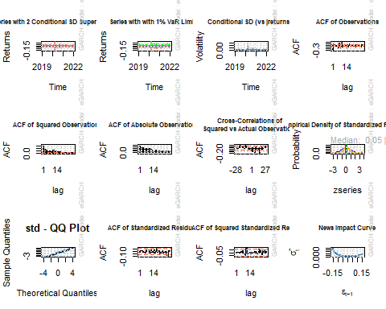 Model convergence

print(convergence(fit_garch_4))

## [1] 0

Forecast the data using GARCH model

for_cast1 <-ugarchforecast(fit_garch_4,data=data,n.ahead=100)  
for_cast1

##   
## *------------------------------------*  
## * GARCH Model Forecast *  
## *------------------------------------*  
## Model: eGARCH  
## Horizon: 100  
## Roll Steps: 0  
## Out of Sample: 0  
##   
## 0-roll forecast [T0=2022-01-21]:  
## Series Sigma  
## T+1 0.011322 0.02412  
## T+2 0.008895 0.02354  
## T+3 0.008589 0.02300  
## T+4 0.008295 0.02250  
## T+5 0.008013 0.02203  
## T+6 0.007743 0.02160  
## T+7 0.007484 0.02120  
## T+8 0.007236 0.02083  
## T+9 0.006999 0.02049  
## T+10 0.006771 0.02017  
## T+11 0.006553 0.01987  
## T+12 0.006344 0.01959  
## T+13 0.006144 0.01932  
## T+14 0.005952 0.01908  
## T+15 0.005768 0.01885  
## T+16 0.005592 0.01864  
## T+17 0.005423 0.01844  
## T+18 0.005261 0.01825  
## T+19 0.005106 0.01807  
## T+20 0.004957 0.01791  
## T+21 0.004815 0.01775  
## T+22 0.004678 0.01761  
## T+23 0.004548 0.01747  
## T+24 0.004422 0.01735  
## T+25 0.004302 0.01722  
## T+26 0.004187 0.01711  
## T+27 0.004077 0.01701  
## T+28 0.003971 0.01690  
## T+29 0.003870 0.01681  
## T+30 0.003773 0.01672  
## T+31 0.003680 0.01664  
## T+32 0.003591 0.01656  
## T+33 0.003506 0.01648  
## T+34 0.003424 0.01641  
## T+35 0.003346 0.01635  
## T+36 0.003271 0.01629  
## T+37 0.003199 0.01623  
## T+38 0.003130 0.01617  
## T+39 0.003064 0.01612  
## T+40 0.003000 0.01607  
## T+41 0.002940 0.01602  
## T+42 0.002882 0.01598  
## T+43 0.002826 0.01594  
## T+44 0.002772 0.01590  
## T+45 0.002721 0.01586  
## T+46 0.002672 0.01583  
## T+47 0.002625 0.01579  
## T+48 0.002580 0.01576  
## T+49 0.002537 0.01573  
## T+50 0.002496 0.01571  
## T+51 0.002456 0.01568  
## T+52 0.002418 0.01565  
## T+53 0.002382 0.01563  
## T+54 0.002347 0.01561  
## T+55 0.002314 0.01559  
## T+56 0.002282 0.01557  
## T+57 0.002251 0.01555  
## T+58 0.002222 0.01553  
## T+59 0.002194 0.01551  
## T+60 0.002167 0.01550  
## T+61 0.002141 0.01548  
## T+62 0.002116 0.01547  
## T+63 0.002092 0.01546  
## T+64 0.002069 0.01544  
## T+65 0.002048 0.01543  
## T+66 0.002027 0.01542  
## T+67 0.002007 0.01541  
## T+68 0.001988 0.01540  
## T+69 0.001969 0.01539  
## T+70 0.001952 0.01538  
## T+71 0.001935 0.01537  
## T+72 0.001919 0.01536  
## T+73 0.001903 0.01535  
## T+74 0.001888 0.01535  
## T+75 0.001874 0.01534  
## T+76 0.001860 0.01533  
## T+77 0.001847 0.01533  
## T+78 0.001835 0.01532  
## T+79 0.001823 0.01532  
## T+80 0.001811 0.01531  
## T+81 0.001800 0.01531  
## T+82 0.001790 0.01530  
## T+83 0.001780 0.01530  
## T+84 0.001770 0.01529  
## T+85 0.001761 0.01529  
## T+86 0.001752 0.01529  
## T+87 0.001743 0.01528  
## T+88 0.001735 0.01528  
## T+89 0.001727 0.01527  
## T+90 0.001720 0.01527  
## T+91 0.001712 0.01527  
## T+92 0.001706 0.01527  
## T+93 0.001699 0.01526  
## T+94 0.001693 0.01526  
## T+95 0.001687 0.01526  
## T+96 0.001681 0.01526  
## T+97 0.001675 0.01525  
## T+98 0.001670 0.01525  
## T+99 0.001665 0.01525  
## T+100 0.001660 0.01525

Rolling forecast

fit_roll <- ugarchfit(garch_4, data= stock_log[1:size], out.sample = 400)  
fore_roll <- ugarchforecast(fit_roll, n.ahead=100, n.roll = 400)  
fore_roll

##   
## *------------------------------------*  
## * GARCH Model Forecast *  
## *------------------------------------*  
## Model: eGARCH  
## Horizon: 100  
## Roll Steps: 400  
## Out of Sample: 100  
##   
## 0-roll forecast [T0=2020-01-29]:  
## Series Sigma  
## T+1 5.124 0.01292  
## T+2 5.124 0.01278  
## T+3 5.125 0.01266  
## T+4 5.125 0.01256  
## T+5 5.126 0.01247  
## T+6 5.126 0.01240  
## T+7 5.127 0.01234  
## T+8 5.127 0.01228  
## T+9 5.127 0.01223  
## T+10 5.128 0.01219  
## T+11 5.128 0.01215  
## T+12 5.129 0.01212  
## T+13 5.129 0.01210  
## T+14 5.129 0.01207  
## T+15 5.130 0.01205  
## T+16 5.130 0.01203  
## T+17 5.131 0.01202  
## T+18 5.131 0.01201  
## T+19 5.131 0.01199  
## T+20 5.132 0.01198  
## T+21 5.132 0.01198  
## T+22 5.133 0.01197  
## T+23 5.133 0.01196  
## T+24 5.133 0.01196  
## T+25 5.134 0.01195  
## T+26 5.134 0.01195  
## T+27 5.134 0.01194  
## T+28 5.135 0.01194  
## T+29 5.135 0.01194  
## T+30 5.135 0.01194  
## T+31 5.136 0.01193  
## T+32 5.136 0.01193  
## T+33 5.136 0.01193  
## T+34 5.137 0.01193  
## T+35 5.137 0.01193  
## T+36 5.137 0.01193  
## T+37 5.138 0.01193  
## T+38 5.138 0.01192  
## T+39 5.139 0.01192  
## T+40 5.139 0.01192  
## T+41 5.139 0.01192  
## T+42 5.139 0.01192  
## T+43 5.140 0.01192  
## T+44 5.140 0.01192  
## T+45 5.140 0.01192  
## T+46 5.141 0.01192  
## T+47 5.141 0.01192  
## T+48 5.141 0.01192  
## T+49 5.142 0.01192  
## T+50 5.142 0.01192  
## T+51 5.142 0.01192  
## T+52 5.143 0.01192  
## T+53 5.143 0.01192  
## T+54 5.143 0.01192  
## T+55 5.144 0.01192  
## T+56 5.144 0.01192  
## T+57 5.144 0.01192  
## T+58 5.144 0.01192  
## T+59 5.145 0.01192  
## T+60 5.145 0.01192  
## T+61 5.145 0.01192  
## T+62 5.146 0.01192  
## T+63 5.146 0.01192  
## T+64 5.146 0.01192  
## T+65 5.146 0.01192  
## T+66 5.147 0.01192  
## T+67 5.147 0.01192  
## T+68 5.147 0.01192  
## T+69 5.147 0.01192  
## T+70 5.148 0.01192  
## T+71 5.148 0.01192  
## T+72 5.148 0.01192  
## T+73 5.149 0.01192  
## T+74 5.149 0.01192  
## T+75 5.149 0.01192  
## T+76 5.149 0.01192  
## T+77 5.150 0.01192  
## T+78 5.150 0.01192  
## T+79 5.150 0.01192  
## T+80 5.150 0.01192  
## T+81 5.151 0.01192  
## T+82 5.151 0.01192  
## T+83 5.151 0.01192  
## T+84 5.151 0.01192  
## T+85 5.152 0.01192  
## T+86 5.152 0.01192  
## T+87 5.152 0.01192  
## T+88 5.152 0.01192  
## T+89 5.153 0.01192  
## T+90 5.153 0.01192  
## T+91 5.153 0.01192  
## T+92 5.153 0.01192  
## T+93 5.153 0.01192  
## T+94 5.154 0.01192  
## T+95 5.154 0.01192  
## T+96 5.154 0.01192  
## T+97 5.154 0.01192  
## T+98 5.155 0.01192  
## T+99 5.155 0.01192  
## T+100 5.155 0.01192

Plot the rolling forecast with unconditional 1-Sigma bands

plot(fore_roll,which=1)

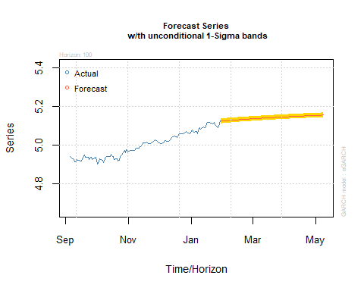

Retrieve data and remove the reference to the stock symbol from column names and add Date as a separate column using the index.

start_date <- Sys.Date() - 1095 #Three years  
end_date <- Sys.Date() - 1  
  
symbol <- "MSFT"  
stock_df <- NULL  
  
  
getSymbols(symbol, verbose = TRUE, src = "yahoo",   
 from=start_date, to=end_date)

## downloading MSFT .....  
##   
## done.

## [1] "MSFT"

# stock_df = as.data.frame(get(symbol))  
  
temp_df = as.data.frame(get(symbol))  
temp_df$Date = row.names(temp_df)  
row.names(temp_df) = NULL  
colnames(temp_df) = c("Open", "High", "Low", "Close",   
 "Volume", "Adjusted", "Date")  
temp_df = temp_df[c("Date", "Open", "High",   
 "Low", "Close", "Volume", "Adjusted")]  
stock_df = rbind(stock_df, temp_df)  
  
head(stock_df)

## Date Open High Low Close Volume Adjusted  
## 1 2019-01-25 107.24 107.88 106.20 107.17 31225600 103.63274  
## 2 2019-01-28 106.26 106.48 104.66 105.08 29476700 101.61172  
## 3 2019-01-29 104.88 104.97 102.17 102.94 31490500 99.54236  
## 4 2019-01-30 104.62 106.38 104.33 106.38 49471900 102.86881  
## 5 2019-01-31 103.80 105.22 103.18 104.43 55636400 100.98316  
## 6 2019-02-01 103.78 104.10 102.35 102.78 35535700 99.38766

Save the data in CSV file for the third model LSTM to be coded using Python.

write.csv(stock_df, 'stock_df.csv')